Take Home Exam 2

Due Tuesday, November 1st, 2016

STAT 4013: Statistical Methods I (FALL 2016)

Directions: This paper is to be the cover page of your exam. All questions are to be typed and attached to the end of this document. You must submit it to D2L **Dropbox** no later **than November 1st, 2016** at **11:59 pm**. This portion of the exam is to test your knowledge of both statistical concepts learned thus far and how to effectively use statistical software (in this case R). All work submitted must be your own. You may use anything at your disposal except another human being. Solutions should be written following all rules of English, and points will be deducted as needed**. Graphics should appear within the solutions, and an appendix with just your R code should be attached at the end.**

**You are allowed only one submission to Dropbox, so make sure your answers are as complete as you want them to be before submitting because there is no going back!!!!**

**Failing to submit your code will result in a reduction of your grade by 20 points.**

***Questions:***

It is that time of year again when “America’s Greatest Homecoming” is upon us. Everyone is excited and ready for the football game against West Virginia University. Even that super nerdy classmate has caught the football bug; however, he decides to turn it into an academic pursuit. He collected data on every team in the Big 12 Conference for the 2015 season. After collecting this data, he comes to you all excited because he wants to perform inferences on all of college football since he believes the Big 12 is a fairly representative sample. You do not want to hurt his feelings by telling him that his sampling method probably was not the best, so you agree to help him out.

The data can be found at <http://rfs.kvasaheim.com/datafiles.php>. The file name is big12football2015.

1. You guys decide to look at the yardsFor variable.
   1. Create a graphic that will let you decide if the data reasonably resembles a normal distribution. Discuss why or why not it looks normal. **(10 points)**
      1. Hint: You have already done this type of graphic before for the last take home.
   2. Do we need to worry about the normality of our random variable if we want to perform a hypothesis test? Why or why not? **(5 points)**
   3. No matter how you answer parts a and b, perform a hypothesis test that the mean number of yards for is greater than 475. Use a Type I error rate of 1%. **(32 points)**
      1. State your hypotheses
      2. State your test statistic
      3. State your decision using the p-value method. You should get an exact probability.
      4. State your conclusion

**Question 1**

**Part A**

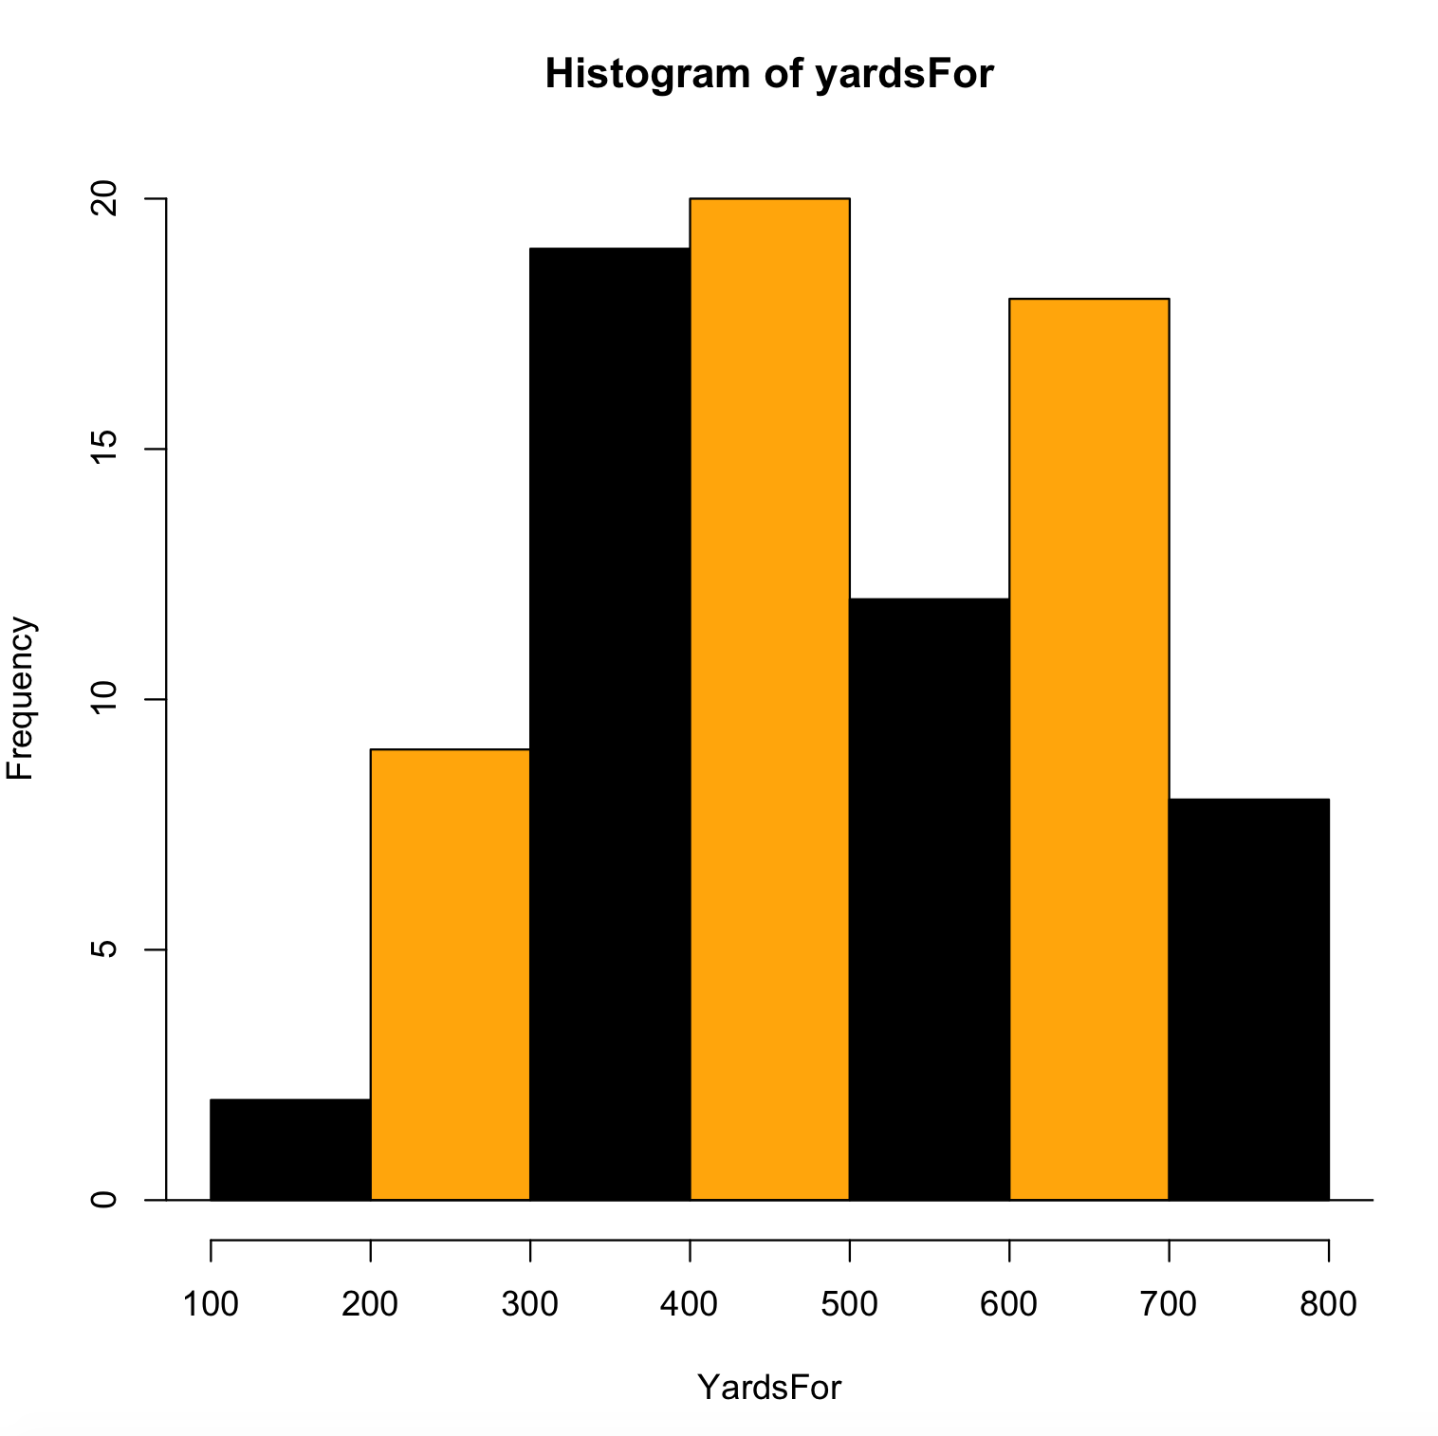

This is looks approximately a normal distribution. It looks approximately mound shaped. Not only that, but also the sample size number of YardsFor is 88 which greater than 30 so it is a normal distribution.

**Part B**

Hypothesis test is robust to normality. This means that even if the distribution is not normal hypothesis test can be performed.

**Part C**

1. H0: μ of YardsFor > 475

Ha: μ for YardsFor <= 475

α = .01

1. I’m going to use Z-test statistic
2. The probability that the mean of YardsFor is greater than 475 is p= 0.5974523.
3. The test statistic 0.5280678 is greater than the critical value of -2.326348.

Hence, at .01 significance level, and p = 0. 5974523 we fail to reject the null hypothesis.

**Appendix**

big12 = read.csv("/Users/thotasairam/Documents/Fall 2016/STAT 4013 - Satistics/TakeHome2/big12football2015.csv")

attach(big12)

names(big12)

* 1. hist(yardsFor, xlab= "YardsFor", col = c( "black","orange"))

abline(h=0)

* 1. length(yardsFor)

#z-score

z = (mean(yardsFor) - 475)/(sd(yardsFor)/sqrt(length(yardsFor)))

2*pnorm(-abs(z)) #pvalue

z.alpha = qnorm(1-.01) #since significance level is .01

-z.alpha #critical value